 

INSTITUTE FOR ADVANCED COMPUTING AND SOFTWARE DEVELOPMENT AKURDI, PUNE

Documentation On

**“ONLINE VOTING SYSTEM”**

e-DAC MAY 2021

*Submitted By:*

**Group No. 34**

**Pranav Kharche (1093)**

**Swapnil Chougule (1040)**

**Mr. Prashant Karhale Mr. Kashinath Patil**

**Centre Coordinator Project Guide**

**Table of Contents**

1. **Introduction** **3**

Document Purpose 3

Product Scope 3

Aim & Objectives 3

1. **Overall Description 4**

Problem Definition 4

Existing System 4

Proposed System 5

Design and Implementation 7

Operating Environment 9

1. **Requirements Specification 10**

External Interface Requirements 10

Non-Functional Requirements 11

1. **System Diagram 11**

ER Diagram 12

Class Diagram 13

Data Flow Diagram 14

Activity Diagram 14

Use Case Diagram 19

1. **Table Structure 21**

Admin 21

Voter 21

Candidate 22

Party 22

Votes 22

1. **Conclusion 23**

Future Scope 30

1. **References 31**

**List of Figures**

|  |  |
| --- | --- |
| Figure | Page No. |
| Figure 1 ER Diagram | 12 |
| Figure 2 Class Diagram | 13 |
| Figure 3 Activity/Sequence diagram for Registration | 13 |
| Figure 4 Activity/Sequence diagram for Login/Logout | 14 |
| Figure 5 Activity/Sequence diagram for Voting | 15 |
| Figure 6 Activity/Sequence diagram for voter &  party account activation | 16 |
| Figure 7 Activity/Sequence diagram for candidate   account activation | 17 |
| Figure 8 Use Case Diagram for Voter | 18 |
| Figure 9 Use Case Diagram for Candidate | 18 |
| Figure 10 Use Case Diagram for Political Party | 19 |
| Figure 11 Use Case Diagram for System Admin | 19 |

**INTRODUCTION**

**Purpose**

The purpose of the document is to make the data design and system architecture of the Online Voting System easy to comprehend. It also serves the purpose of making the functionality clear to system designers.

**Social Requirements**

The various social requirements for the effectual key for online base voting in website are listed below.

**Minimum Computer Knowledge**

The voters, candidates and those who have to involve should have minimum computer operation skills and online operation skills.

**Scope:**

Manual voting system has been deployed for many years in our country. However, in many parts of our country people cannot attend the voting because of several reasons. In order to solve these problems there is a need of online voting system in addition to manual voting system. The long-term goal of this project is to greatly reduce the cost and complexity of running elections and increase the accuracy of results by removing the direct involvement of humans in gathering and counting of votes. The voters will be able to give their votes at any field areas by using the system if they prefer online voting. In this system, the voter votes using Java application which can be downloaded over internet.

**Objective:**

The main objective of the proposed solution is to be automated the voting process and activities related to voting process through Internet. This solution will facilitate the voters and candidates with the different modules. This solution is very much necessary for the elections in the local bodies as well as general body.

**Problem Definition:**

**User Friendly**

The solution provides very simple and modified features, which are very easy to use. The said project is designed and organized in very simplified manner to suit the current requirements of the voters and nominees such as voting, counting of votes, registration of voters and candidates which are done by the admin.

**Voting Management**

The voting made through either net or manually in elections need to have consistency and uniqueness with respect to the voter, nominee and division related details.

**Security**

The effectual key for aadhar base voting system deals with the prompt voting process

that is there is no malicious and unauthorized voting is done. This also ensures that the single voter will not be allowed to vote in the same election in any division not more than once, which is prime aspect of the voting process. The security is at two different levels, one at voter details and other at administrative level.

**EXISTING SYSTEM:**

Present Election System was based on the Electronic voting system, for polling initially committee should verify the persons for authentication that is purely based on the manual system and verifies voter identity card for authentication. Developed countries like United States of America are already using these kinds of applications.

Drawbacks:

* Manual system
* Long process for authenticating
* There may be chance for rig.

**PROPOSED SYSTEM:**

Now a day’s mobile phones are widely used, it is possible the development of applications for worldwide popular participation by digital vote using mobiles. It is application for voting (polling) purpose. Application is based on Client-Server Architecture. At server site, we are storing a database globally. System is divided into three main parts one is Server, second is Java client

In Java client application, Voters can register their name, documents (like aadhar info) info for further authentication. The system can have numbers of java clients. Each java client can view candidate information, information about different parties and can submit the vote and also can see newly updated status of election. Voting has been used in lots of countries with the development of the E-government technologies in the past years. Generally, in these countries the electronic voting is supervised by the presence of the independent electoral authorities. The specific electronic voting machines are used at polling stations for the voting operation. Manual voting system has been deployed for many years in our country. However, in many parts of our country people cannot attend the voting because of several reasons, sometimes people may not be in their own region and due to this fact they cannot do voting. In order to solve these problems there is a need of electronic voting system in addition to manual voting system. After registering to system, the voters will vote from any region by using proposed system from their device if they are valid voters.

**Advantages**

1) Through this web application we can save the time, we can efficiently get succeed in implementing all the information within short span of time.

2) With the help these projects easily making voting through the internet in all democratic countries like India.

**MODULE DESIGN:**

The major modules of the project are

**1. Registration**

* That system will be used only by the people who have been registered to the system. Main actor of the registration operator is the voters & candidates.
* For security purpose, System can generate user id & password.

**2. Login as a voter**

1) The voter enters his/her login id and password

* If the login and password is valid, a session is opened
* If the login or password is not valid, the login screen is redisplayed with an error message

2) View Parties

* Voters can view party details.

3) View Candidates

* Voter can view candidate details (Which party and constituency they belong to)

4) Vote

* Voter can enter his account using id and password.
* After selecting view candidates, display the names, symbols and parties of the candidates and also display “vote button”.

5) Logout

* The voter clicks on the logout button.
* The session is terminated and the login screen is displayed.

**3. Login as a candidate**

1) The candidate enters his/her login id and password

* If the login and password is valid, a session is opened
* If the login or password is not valid, the login screen is redisplayed with an error message

2) View Votes

* Candidates can view votes.

3) Logout

* The candidate clicks on the logout button.
* The session is terminated and the login screen is displayed.

**4. Login as a Political Party**

1) The Party enters his/her login id and password

* If the login and password is valid, a session is opened
* If the login or password is not valid, the login screen is redisplayed with an error message

2) View Candidates

* Party can view Candidate list and check the list.

3) Activate Candidate account

* Candidate sends request to activate their account, party will approve this request.

3) Logout

* The Party clicks on the logout button.
* The session is terminated and the login screen is displayed.

**5. System/Admin**

1) Admin enters his/her login id and password

* If the login and password is valid, a session is opened
* If the login or password is not valid, the login screen is redisplayed with an error message

2) View Parties

* Admin can view the list of parties and check the information.

3) View Candidates

* Admin can view the list of candidates and check the information.

4)View Voter

* Admin can view the list of voters and check the information.

**6) View Results**

* Admin can click on “View Votes” and see result and declares the result.

**7) Activate Account**

* Admin will activate Voter and Political Party account.
* Political Party will activate Candidate account.

**SYSTEM REQUIREMENTS:**

This section elaborates on the functional requirements of the application. The SRS itself can be divided into module, each module having specifications. In order to carry out the project, the following hardware and software is required.

**HARDWARE REQUIREMENTS:**

* System : i3 processor
* Hard Disk : 1 TB.
* Monitor : 15 VGA Colour.
* Mouse : Logitech.
* Ram : 4GB.

**SOFTWARE REQUIREMENTS:**

Technology **:**  Java 2 Standard Edition, JDBC

Web Server  **:** Tomcat 7.0

Client Side Technologies **:** HTML, CSS, JavaScript

Server Side Technologies **:** Servlets, JSP

Data Base Server **:** MySQL

**Non-Functional Requirements:**

**1. Efficiency Requirement**

When the Online Voting system will be implemented, Election Commission and the voters will have an easy access to cast vote since they need not manually go to the Voting Booth during each Voting season.

**2. Security Requirements**

The data transaction between client and server must be encrypted using SSL technology.

All the passwords that are generated or accepted must be stored in database in an encrypted form.

**3. Reliability Requirement**

The system should accurately perform voter validation, vote casting, report generation, party and candidate information retrieval and search.

**4. Usability Requirement**

The system is designed for a user friendly environment so that voters and candidates can perform the various tasks easily and in an effective way.

**5. Safety requirements**

To prevent data loss in case of system failure, the result of votes that are polled till then have to be saved in database.

In case admin detects any security problem in the system, he should be able to shut down the system and prevent all connection to the server immediately to preserve already polled votes.

**6. User requirements**

Accessibility has become an increasing requirement in services provided by service providers.

They have a high awareness level of various accessibility standards and guidelines.

**7. Policies**

The system should adhere to all the legal formalities of the particular countries.

The system should maintain security related to sensitive data.

**System Diagrams:**

**ER Diagram**

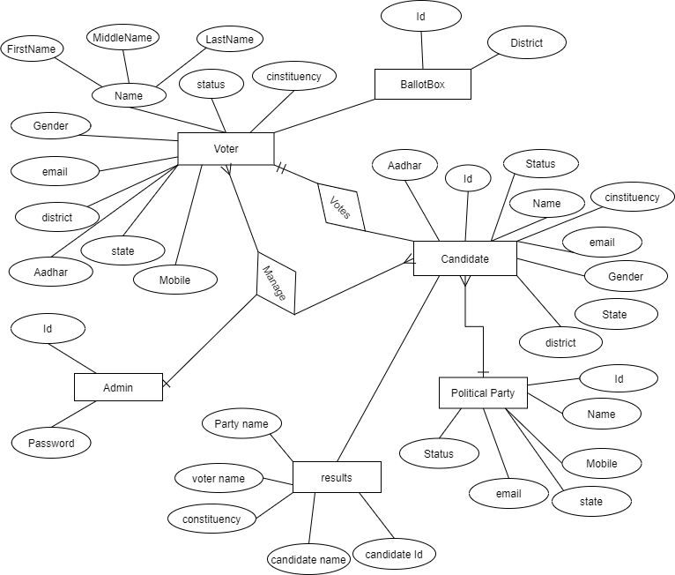

Figure 1

**Class diagram**

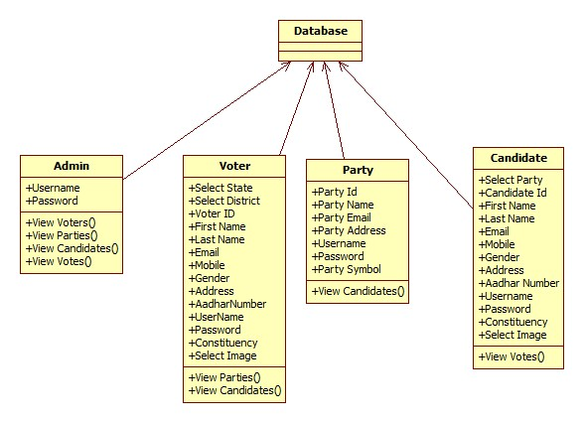

Figure 2

**Activity/Sequence diagram for Registration**

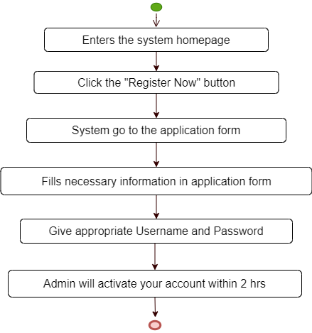

Figure 3

**Activity/Sequence diagram for Login/Logout**

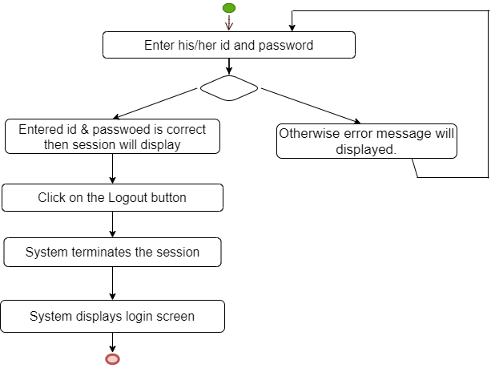

Figure 4

**Activity/Sequence diagram for Voting**

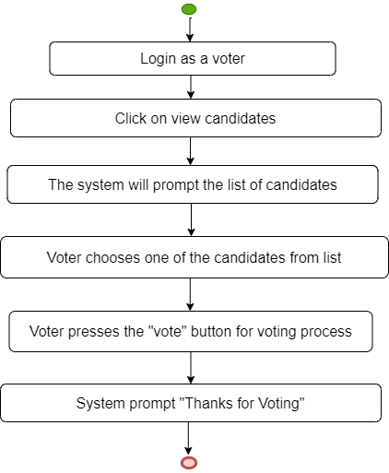

Figure 5

**Activity/Sequence diagram for voter & party account activation**

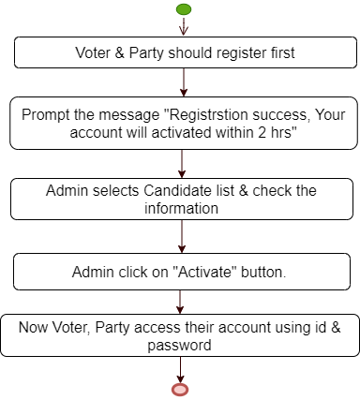

Figure 6

**Activity/Sequence diagram for candidate account activation**

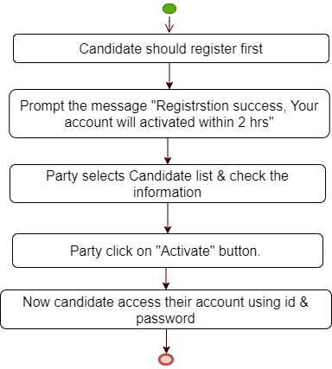

Figure 7

**Use Case Diagram**

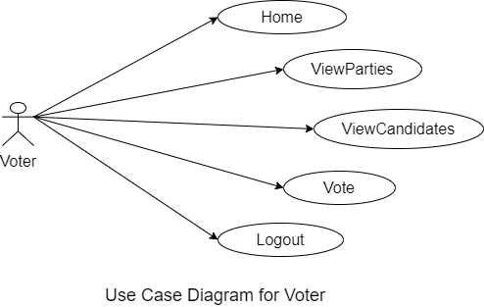

Figure 8

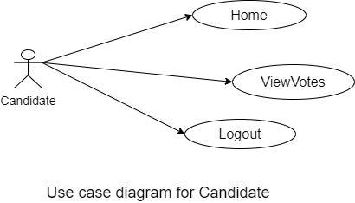

Figure 9

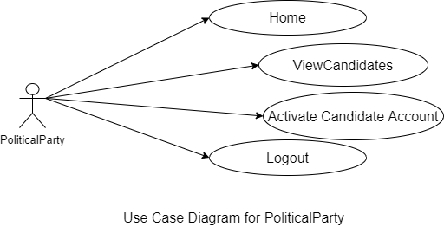

Figure 10

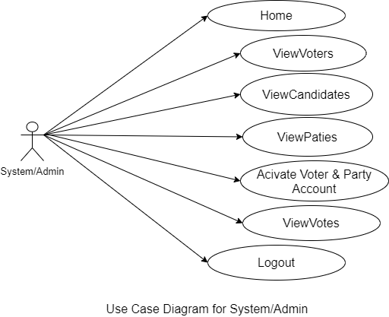

Figure 11

**Table structure:**

**Admin**

|  |  |  |  |  |
| --- | --- | --- | --- | --- |
| Field | Type | Null | Key | Default |
| username | Varchar(50) | NO |  | NULL |
| password | Varchar(50) | NO |  | NULL |

**Voter**

|  |  |  |  |  |
| --- | --- | --- | --- | --- |
| Field | Type | Null | Key | Default |
| State | Varchar(50) | No |  | NULL |
| District | Varchar(50) | No |  | NULL |
| Vid | Varchar(50) | No | PRI | NULL |
| Fname | Varchar(50) | No |  | NULL |
| Lname | Varchar(50) | No |  | NULL |
| Email | Varchar(50) | No |  | NULL |
| Mobile | Varchar(50) | No |  | NULL |
| Gender | Varchar(50) | No |  | NULL |
| address | Varchar(50) | No |  | NULL |
| Aadhar | Varchar(50) | No |  | NULL |
| username | Varchar(50) | No |  | NULL |
| password | Varchar(50) | No |  | NULL |
| constituency | Varchar(50) | No |  | NULL |
| Image | longlob | No |  | NULL |
| Status | Varchar(50) | No |  | NULL |

**Candidate**

|  |  |  |  |  |
| --- | --- | --- | --- | --- |
| Field | Type | Null | Key | Default |
| pname | Varchar(50) | No |  | NULL |
| cid | Varchar(50) | No | PRI | NULL |
| fname | Varchar(50) | No |  | NULL |
| lname | Varchar(50) | No |  | NULL |
| Email | Varchar(50) | No |  | NULL |
| mobile | Varchar(50) | No |  | NULL |
| gender | Varchar(50) | No |  | NULL |
| address | Varchar(50) | No |  | NULL |
| aadhar | Varchar(50) | No |  | NULL |
| username | Varchar(50) | No |  | NULL |
| password | Varchar(50) | No |  | NULL |
| constituency | Varchar(50) | No |  | NULL |
| Image | longlob | No |  | NULL |
| status | Varchar(50) | No |  | NULL |

**Party**

|  |  |  |  |  |
| --- | --- | --- | --- | --- |
| Field | Type | Null | Key | Default |
| Pid | Varchar(50) | No | PRI | NULL |
| pname | Varchar(50) | No |  | NULL |
| fname | Varchar(50) | No |  | NULL |
| pmobile | Varchar(50) | No |  | NULL |
| paddress | Varchar(50) | No |  | NULL |
| username | Varchar(50) | No |  | NULL |
| password | Varchar(50) | No |  | NULL |
| Image | longlob | No |  | NULL |
| status | Varchar(50) | No |  | NULL |

**Votes**

|  |  |  |  |  |
| --- | --- | --- | --- | --- |
| Field | Type | Null | Key | Default |
| pname | Varchar(50) | No |  | NULL |
| cid | Varchar(50) | No |  | NULL |
| cname | Varchar(50) | No |  | NULL |
| constituency | Varchar(50) | No |  | NULL |
| vname | Varchar(50) | No |  | NULL |

**SnapShots**

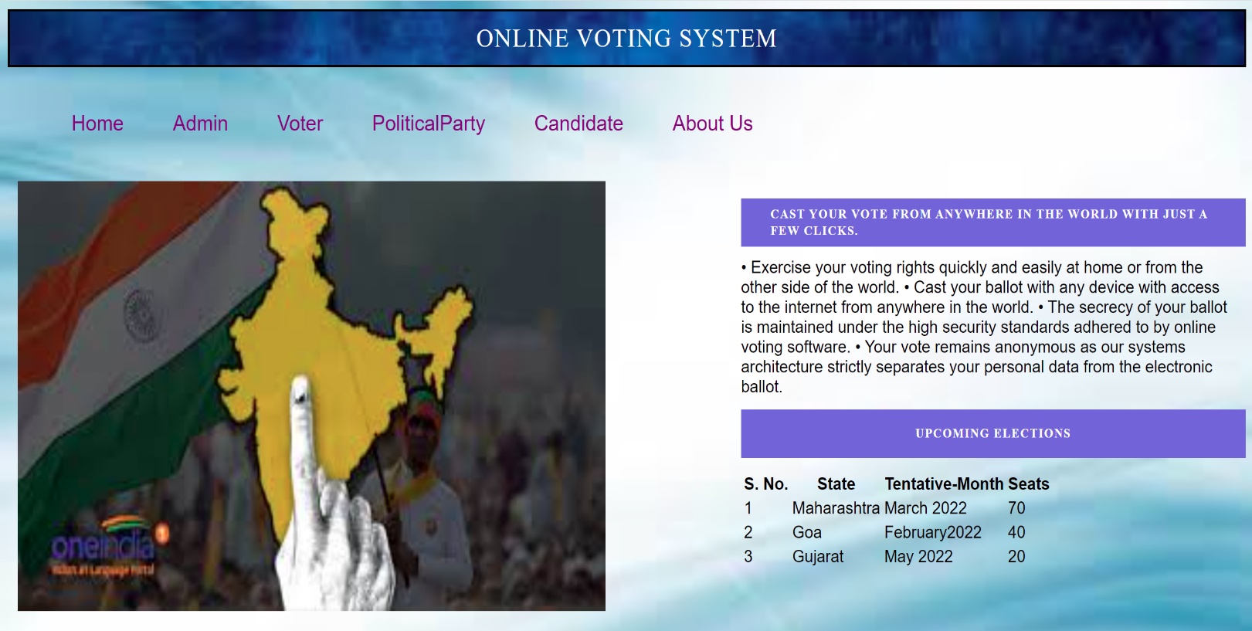

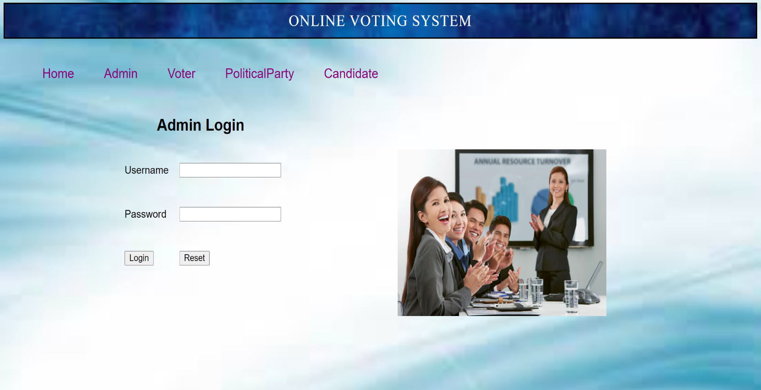

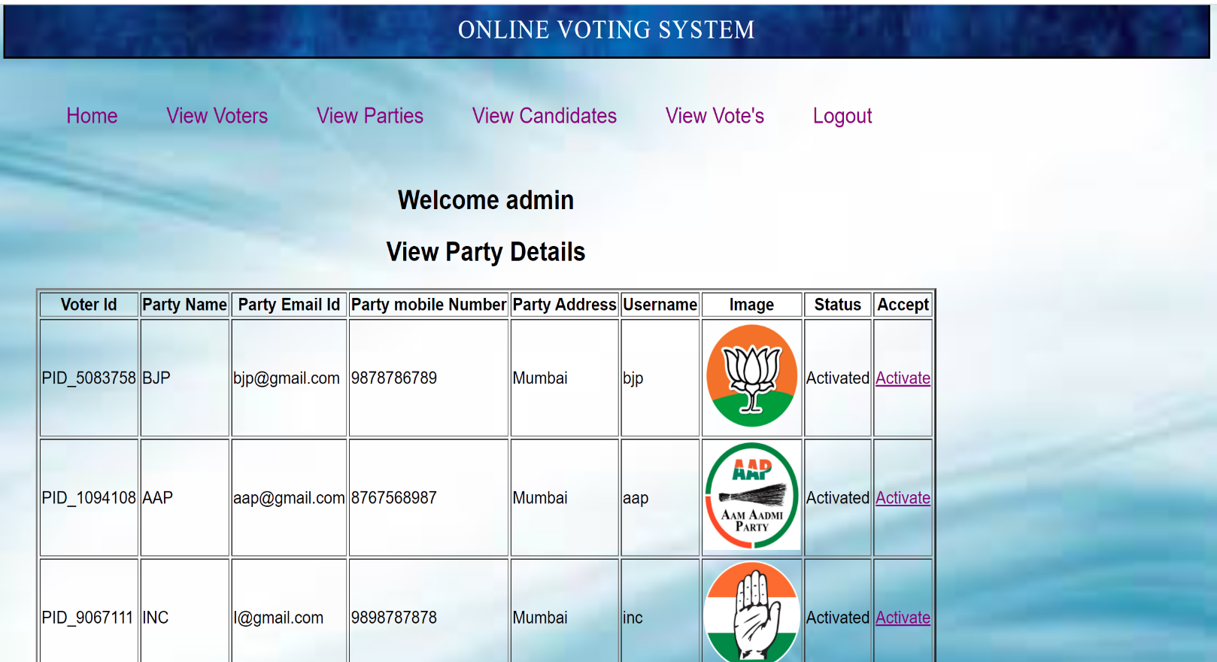

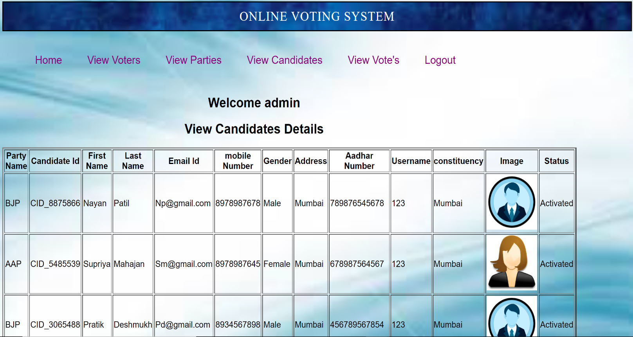

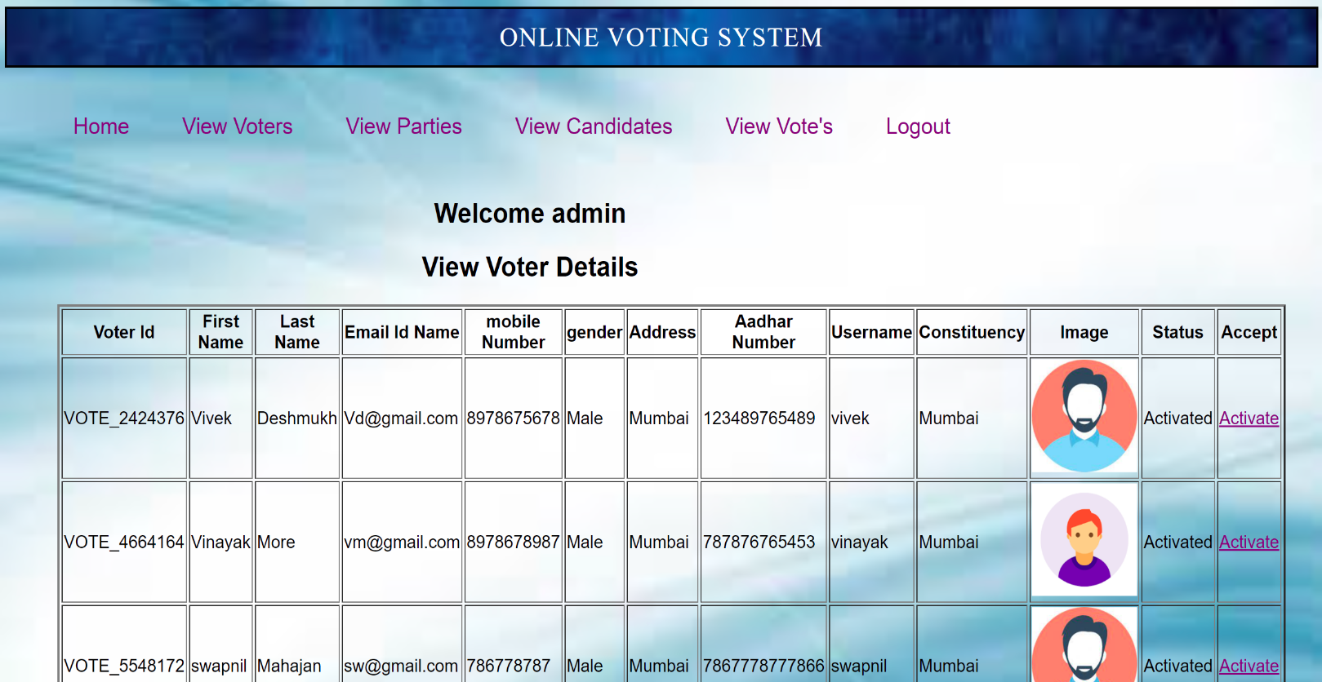

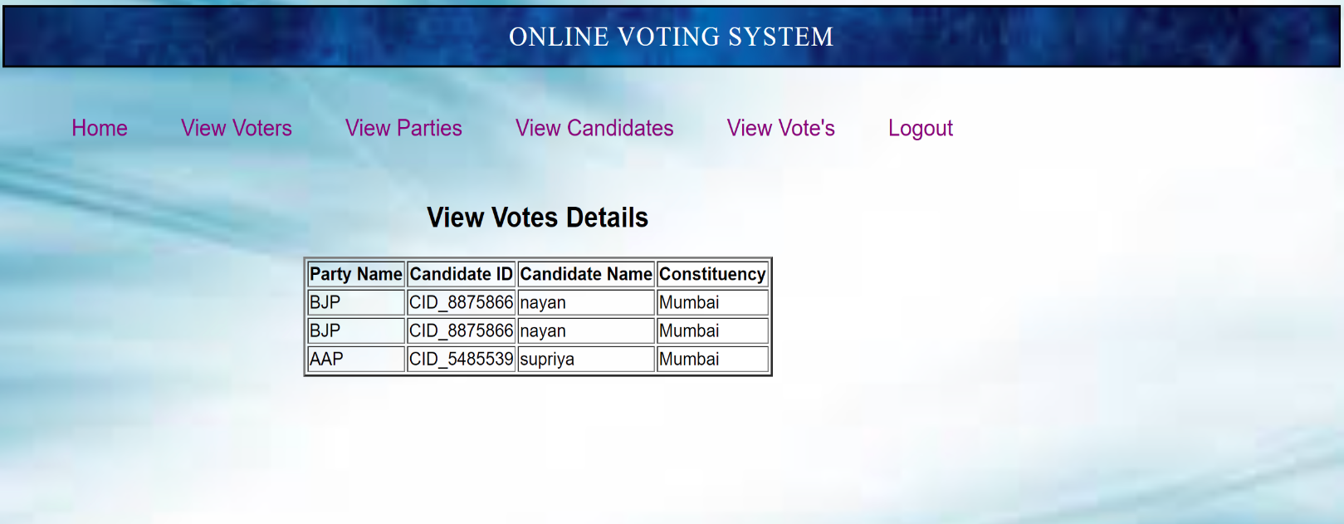

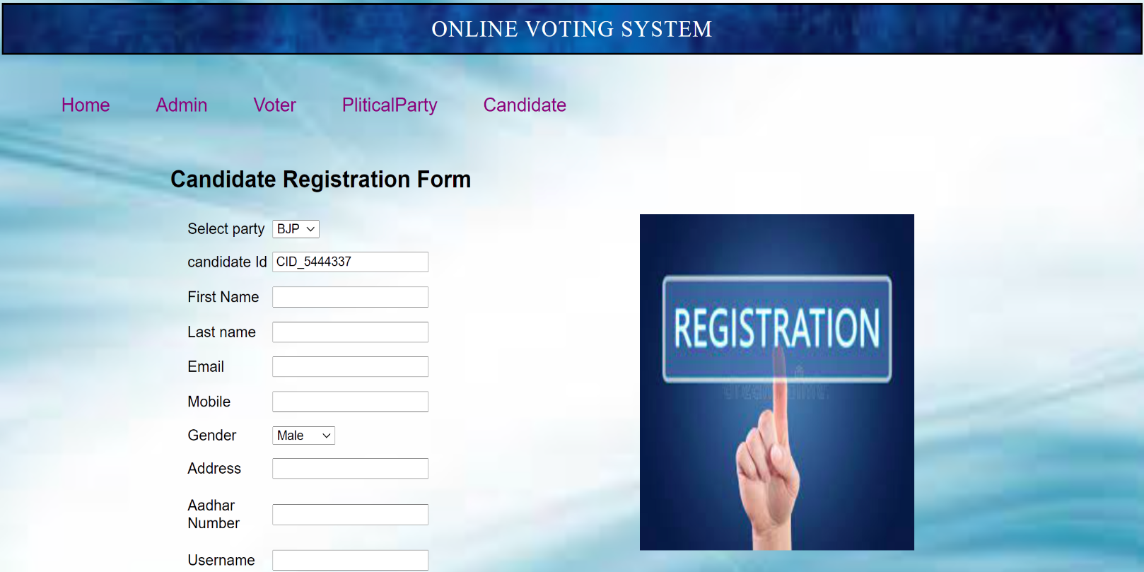

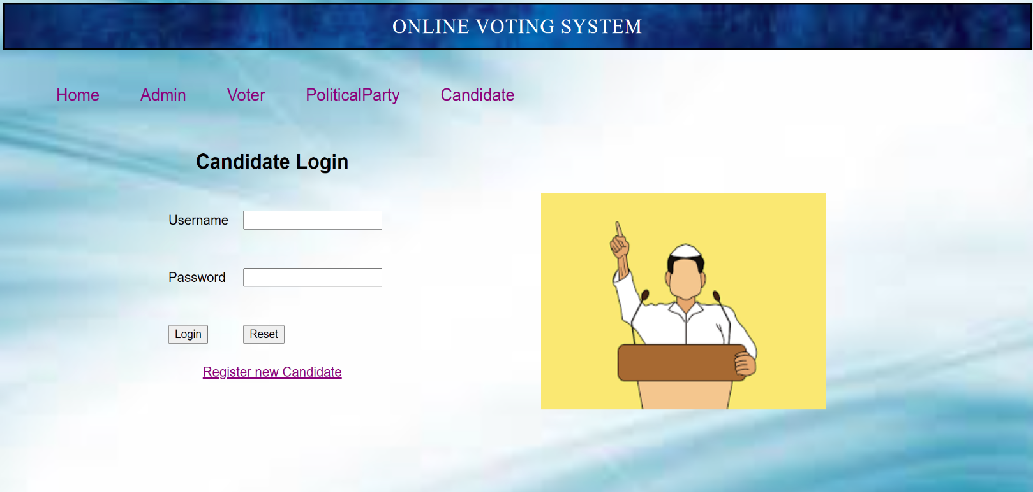



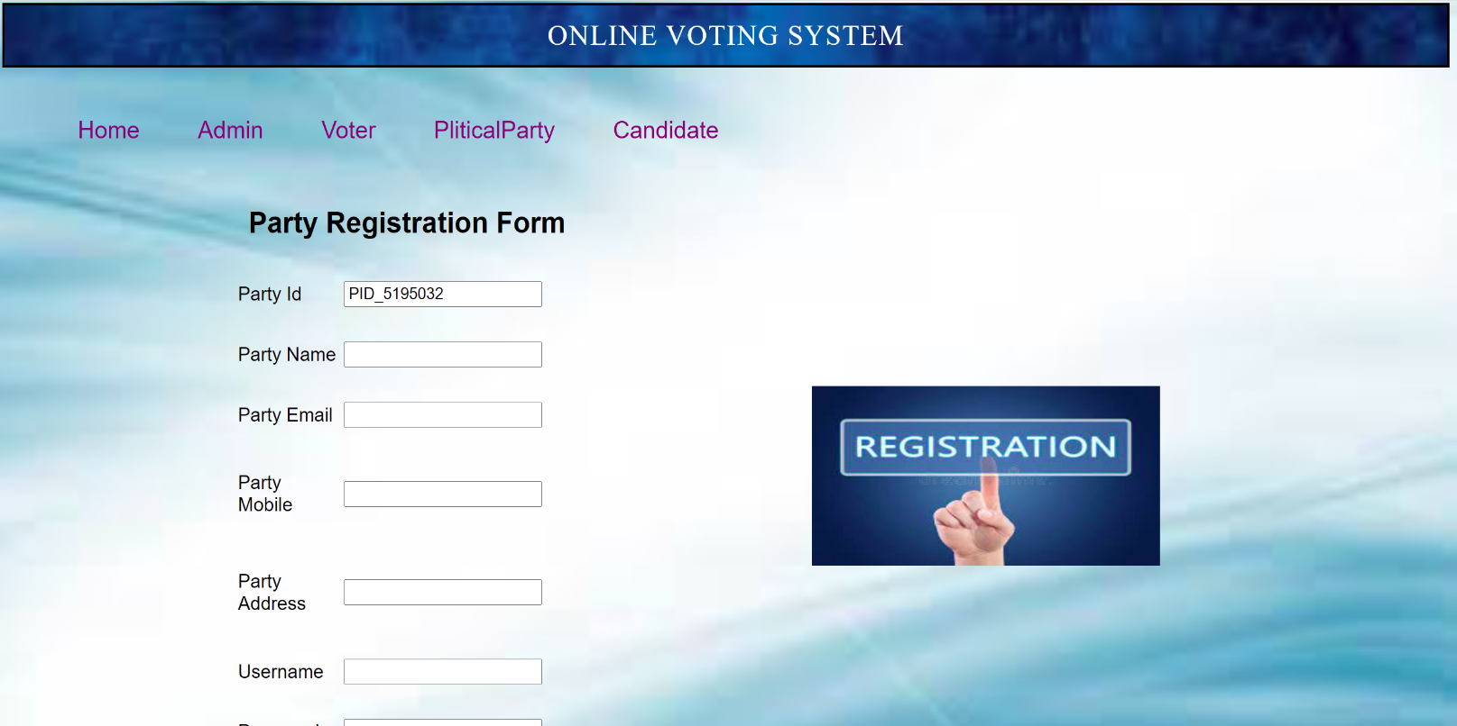



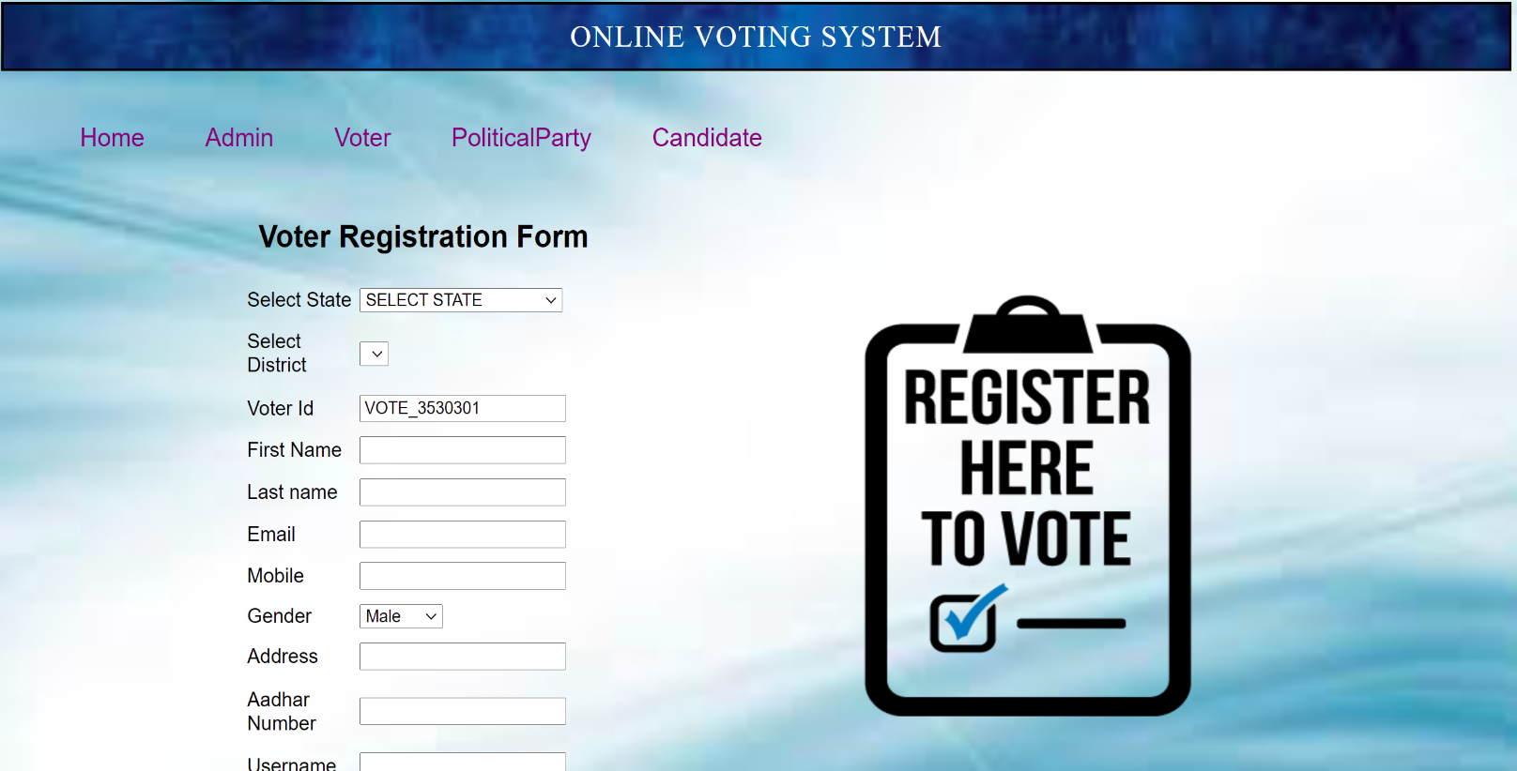

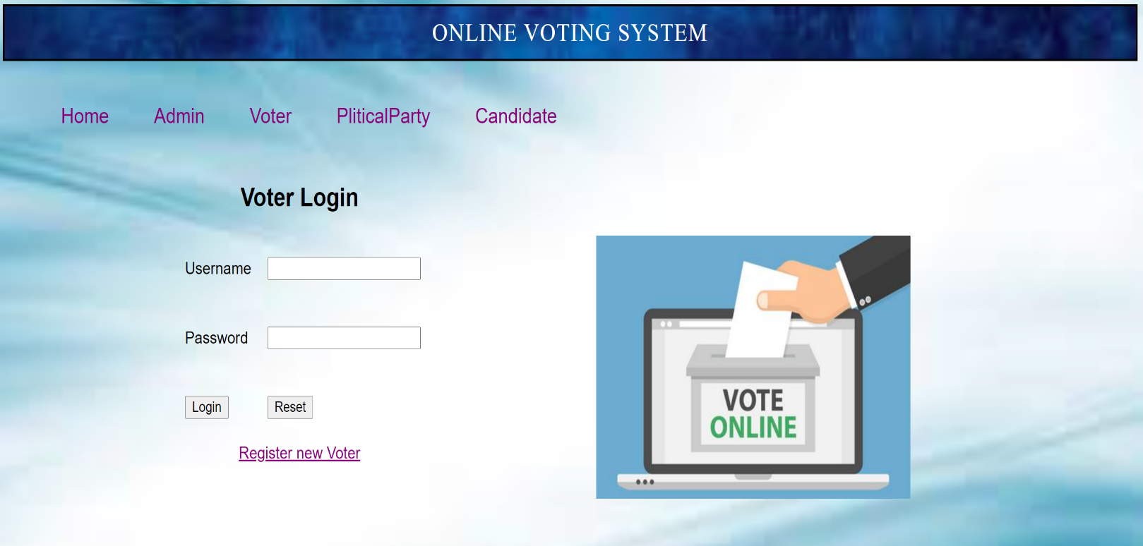

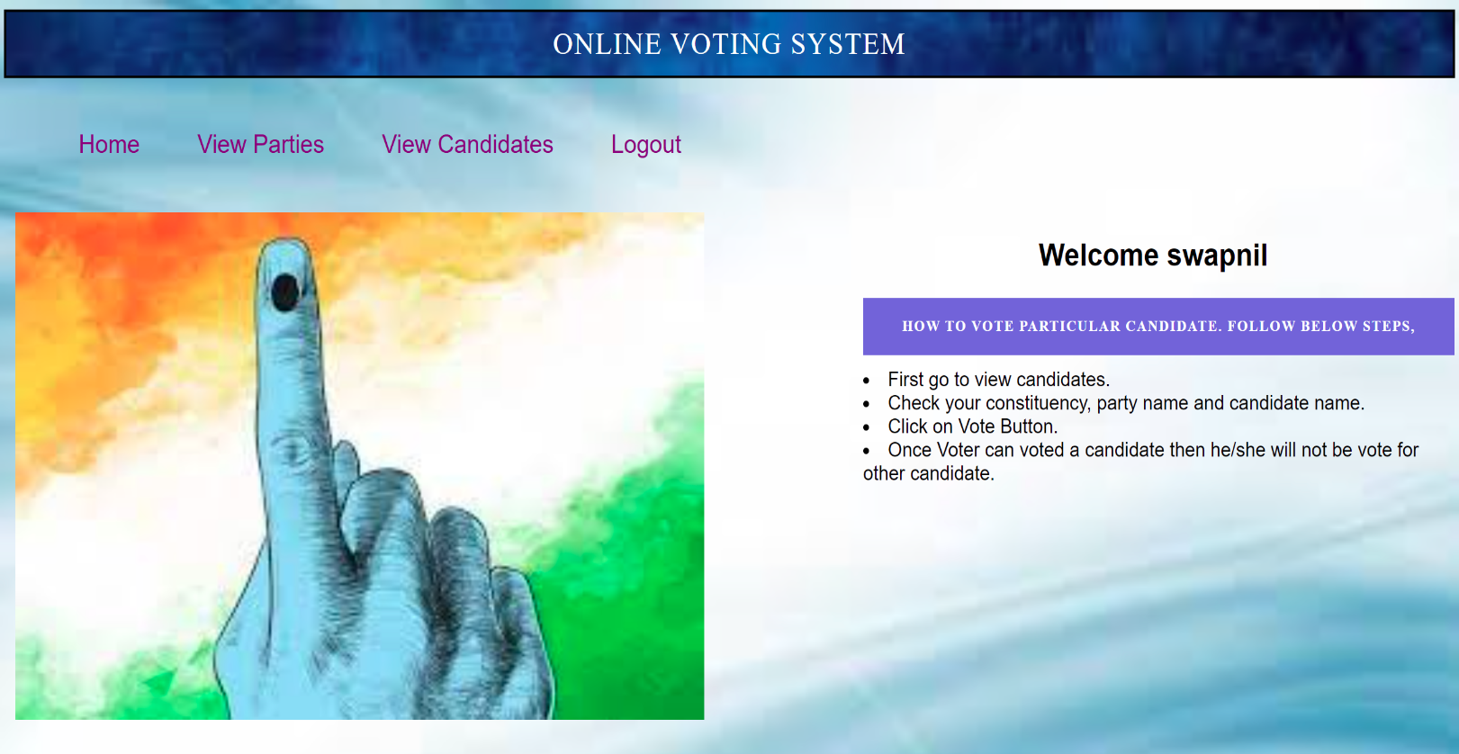

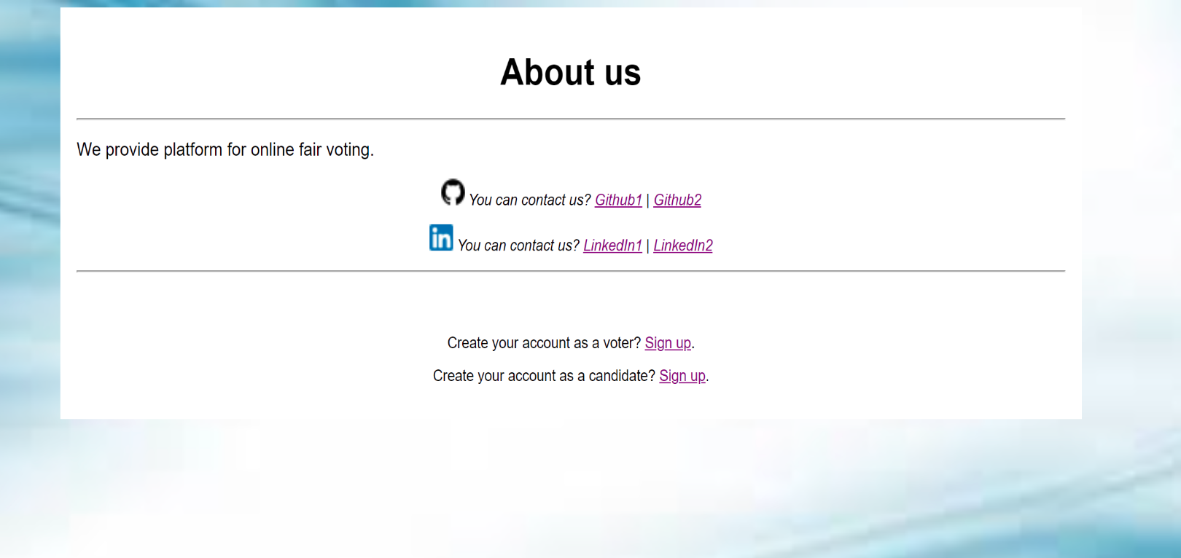

**Future Scope**

The primary objective of this project is to provide a simple, secure and efficient

platform to declare candidature for election, cast a vote and display the results as per the

votes. Online Voting System has successfully managed to achieve the objectives of project.

Progressive work on this project will led to achievement of greater objectives.

The future scope for this project include

* delivering the winning candidate based on number of votes.
* Carrying out multiple election events at the same time.

**References**

* [www.javatpoint.com](http://www.javatpoint.com)
* [www.w3schools.com](http://www.w3schools.com)
* [www.tutorialspoint.com](http://www.tutorialspoint.com)
* [www.askjeeves.com](http://www.askjeeves.com)